Name______________________________________________Period_______________Date__________________

Rock Cycle Dice Game: Student Sheet

**Introduction:** Rock particles travel through Earth’s crust in the “Rock Cycle”. It is called a cycle because a rock particle can travel through it over and over again in a circular way or sometimes not. In this activity you will model the movement of a rock particle through time. You will have about 20 minutes to complete your travels.

**Materials:** lab stations, rocks, rock dice

**Procedures:**

1. You will be starting at an assigned station. Spread out around the room. If a station is too crowded at the beginning, choose to begin at a different station.

2. Roll the die at the station and move to the station indicated by the die. READ THE DIE CAREFULLY, some of the stations are similarly named.

3. Each time you visit a station, make a tally mark in the box (see below) for that station. **Each mark represents approximately 200,000 years in the life of a rock**.

4. As you travel from one station to another, draw an arrow from the station you left to the station you are going to. These arrows represent the transformations that can occur to rock during the rock cycle.

5. If you stay put, make a tally mark and draw an arrow that loops back on itself.

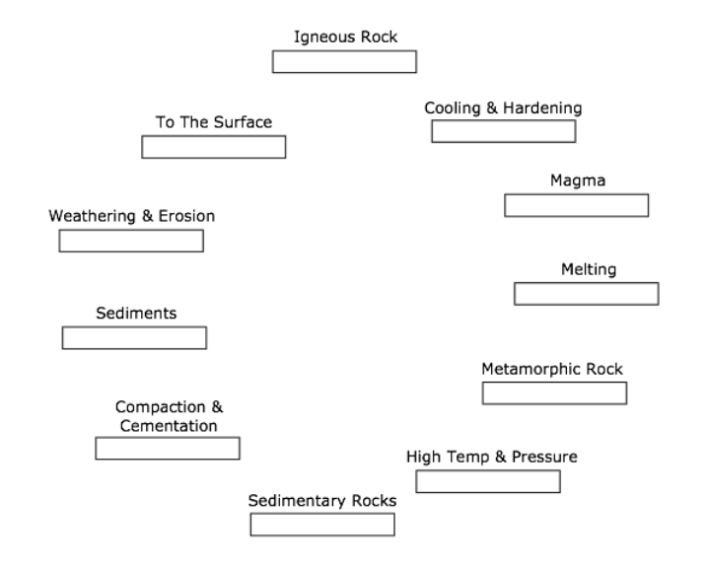

**Analysis:**

1. Where did you get “stuck” in the rock cycle?
2. Why might rock get “stuck” there?
3. Did others in the class get stuck in the same place?
4. How does this model of the rock cycle differ from one pictured in your textbook?
5. What forces move rock through the rock cycle?

**Conclusion:**

1. In two well- written paragraphs complete the following. Explain how rocks move through the rock cycle. Do they always go in the same direction? Explain how rocks might stay in the same part of the cycle. Explain the rate of change for the rocks (how fast or slow they move through the cycle). Does every rock go through the same process?